PRESS RELEASE
COMMUNICATIONS AND MEDIA TEAM OF THE 43RD ASEAN SUMMIT 2023
No. 42/SP/TKM-ASEAN2023/ENG/9/2023

Journalists Utilize Free Shuttle Buses to Media Center for the 43rd ASEAN Summit
Jakarta, 3 September 2023 – Journalists covering the 43rd ASEAN Summit can use a free shuttle bus service from several pickup points to arrive at the Media Center for the 43rd ASEAN Summit at the Jakarta Convention Center (JCC) in the Gelora Bung Karno Complex, Jakarta.
According to the on-site report by the Communications and Media Team of the 43rd ASEAN Summit 2023, journalists, both individuals and groups, have been riding these buses from morning to evening since 31 August.
“We have started transporting people to the JCC area since 31 August 2023,” said bus driver Sunarso (62) to InfoPublik on Sunday (3 September 2023). The transportation mode consists of buses with a size of 3/4 that can accommodate up to 30 people.
According to Sunarso, buses of this size are more maneuverable in the congested streets of Jakarta. This makes them more efficient for transporting passengers to various locations around the JCC area.
“The bus uses a smaller and more efficient engine than a full-size bus,” said Sunarso.
The Communications and Media Team of the 43rd ASEAN Summit 2023 tried the free bus service this afternoon. The journey from the Best Western Hotel in the Senayan area to the Media Center at JCC took 20 minutes. The bus stopped at the back entrance of the Media Center since the front entrance was being used for preparations to welcome the delegations.
Passengers are pampered with comfortable seats, air conditioning, and entertainment facilities. The bus starts operating at 05:00 AM local time and departs every 15 minutes.
The 3/4 size buses can be found in various configurations and are manufactured by different companies, including manufacturers like Ford, Mercedes-Benz, and Iveco. The specific models and features will vary depending on the manufacturer and customer needs.
The shuttle service will serve four routes. Route 1 is serving drop-off/pickup points at Best Western Hotel Senayan, Hotel Century, Hotel Mulia Senayan, TVRI, Spark, and Hall B JCC. This route operates from 1 – 6 September 2023, from 05:00 AM to 09:30 PM local time.
Route 2 serves the Best Western Hotel Senayan, the Ministry of Education, Culture, Research and Technology (Kemendikbud), Gate 7 GBK, The Sultan Hotel, and Hall B JCC. This route operates from 1 – 6 September 2023, from 05:00 AM to 09:30 PM.
Route 3 serves the Blue Line Kominfo from Istora Mandiri MRT Station to Gate 9 GBK. This route operates from 1 – 6 September 2023, from 05:00 AM to 09:30 PM.
Route 4 serves Soekarno-Hatta Airport, Ritz Carlton Pacific Place, The Langham, Fairmont Hotel, Mulia Hotel, and Best Western Hotel Senayan. This route operates from 31 August to 6 September 2023, from 05:00 AM to 10:00 PM local time. (Toro/Donna/Elvira/Wisnu)
***
For more information, please contact:
Director General of Public Information and Communications of the Ministry of Communications and Informatics – Usman Kansong (0816785320).
Get more information at http://asean2023.id, https://infopublik.id/kategori/asean-2023, and https://indonesia.go.id/kategori/ragam-asean-2023

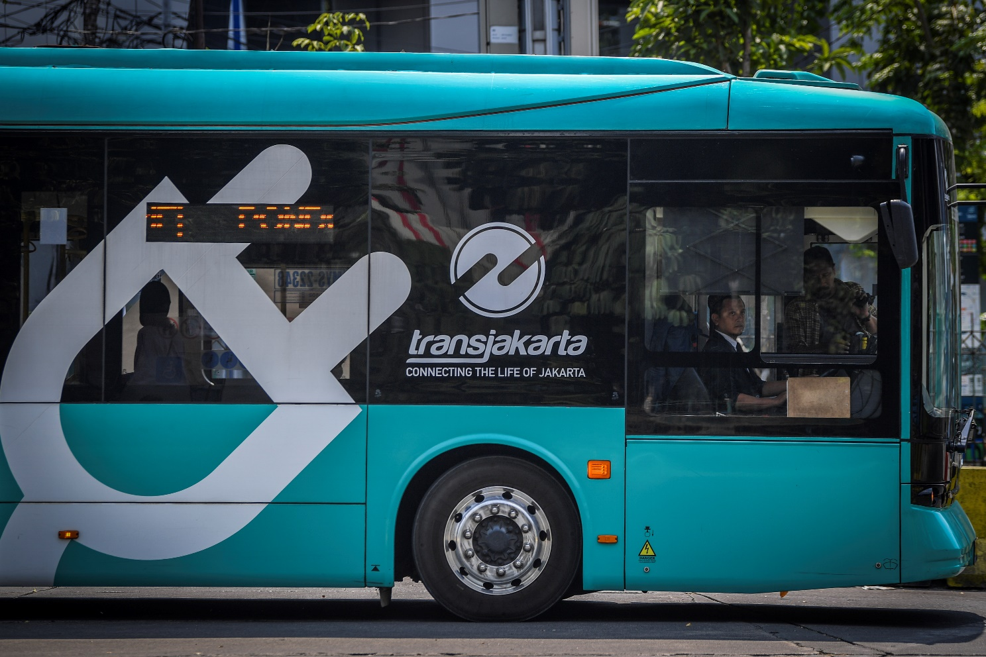
Illustration: Residents board an electric bus at the Blok M Terminal in Jakarta, on Thursday (24 August 2023). PT Transportation Jakarta (Transjakarta) has already put into operation a total of 54 electric buses and aims to increase the fleet to 100 units by the end of 2023. This is part of the efforts to reduce carbon emissions and improve air quality in Jakarta. ANTARA FOTO/Galih Pradipta/nym.

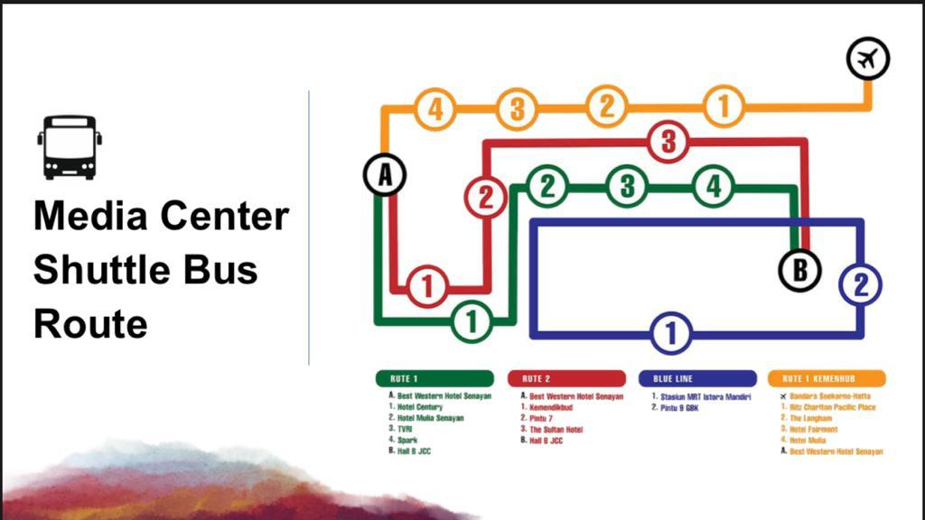

The organizing committee of the 43rd ASEAN Summit 2023 has prepared a free shuttle bus service to the Media Center at the Jakarta Convention Center (JCC), Jakarta, on 5 – 7 September 2023.

